SECTION 1 Diagnostic questionnaire

Instructions: Please answer the following questions as yes or no. We will ask about numbness which some people describe as having no feeling or dead feeling. We will also ask about tingling which some people call pins and needles or prickly feelings. Please pick the answer about how your hand has felt over the last month.

1 | Do you wake up because of tingling or numbness in your thumb, index, and/or middle finger(s)? | Yes (1) No (0)
2 | Do you have tingling or numbness in your thumb, index, and/or middle finger(s) when you first wake up? | Yes (1) No (0)
3 | Is your numbness or tingling mainly in your thumb, index, and/or middle finger(s)? | Yes (1) No (0)
4 | Do you have aching in your wrist? | Yes (1) No (0)
5 | Do you have any quick movements or positions that relieve your tingling or numbness?  Do you find that changing position or shaking your hand relieves your tingling or numbness? | Yes (1) No (0)
6 | Do you have numbness or tingling in your little (small/pinky) finger? | Yes (-2) No (0)
7 | Do certain activities (for example, holding objects or repetitive finger movement) increase the numbness or tingling in your fingers?  Do certain activities (for example, typing/texting, knitting, or holding tools) increase the numbness or tingling in your fingers? | Yes (1) No (0)
8 | Do you drop small objects like coins or a cup?  Do you drop things like coins, or your cup? | Yes (1) No (0)
9 | Do you often have neck pain? | Yes (-1) No (0)
10 | Did you have numbness or tingling in your fingers when you were pregnant? (If relevant) | Yes (1) No (-1)  Not relevant to me (0)
11 | Do you have numbness or tingling in your toes? | Yes (-2) No (0)
12 | Have your symptoms improved with using wrist support, brace, or splint? | Yes (2) No (0)  I have not tried (0)
SECTION 2 Hand diagrams

By clicking on/shading the hand diagram (Left and Right) below, please show where you have experienced TINGLING (pins and needles sensation) on the front of your hands/fingers in the last month. (Click next if it does not apply)

Front of Hands

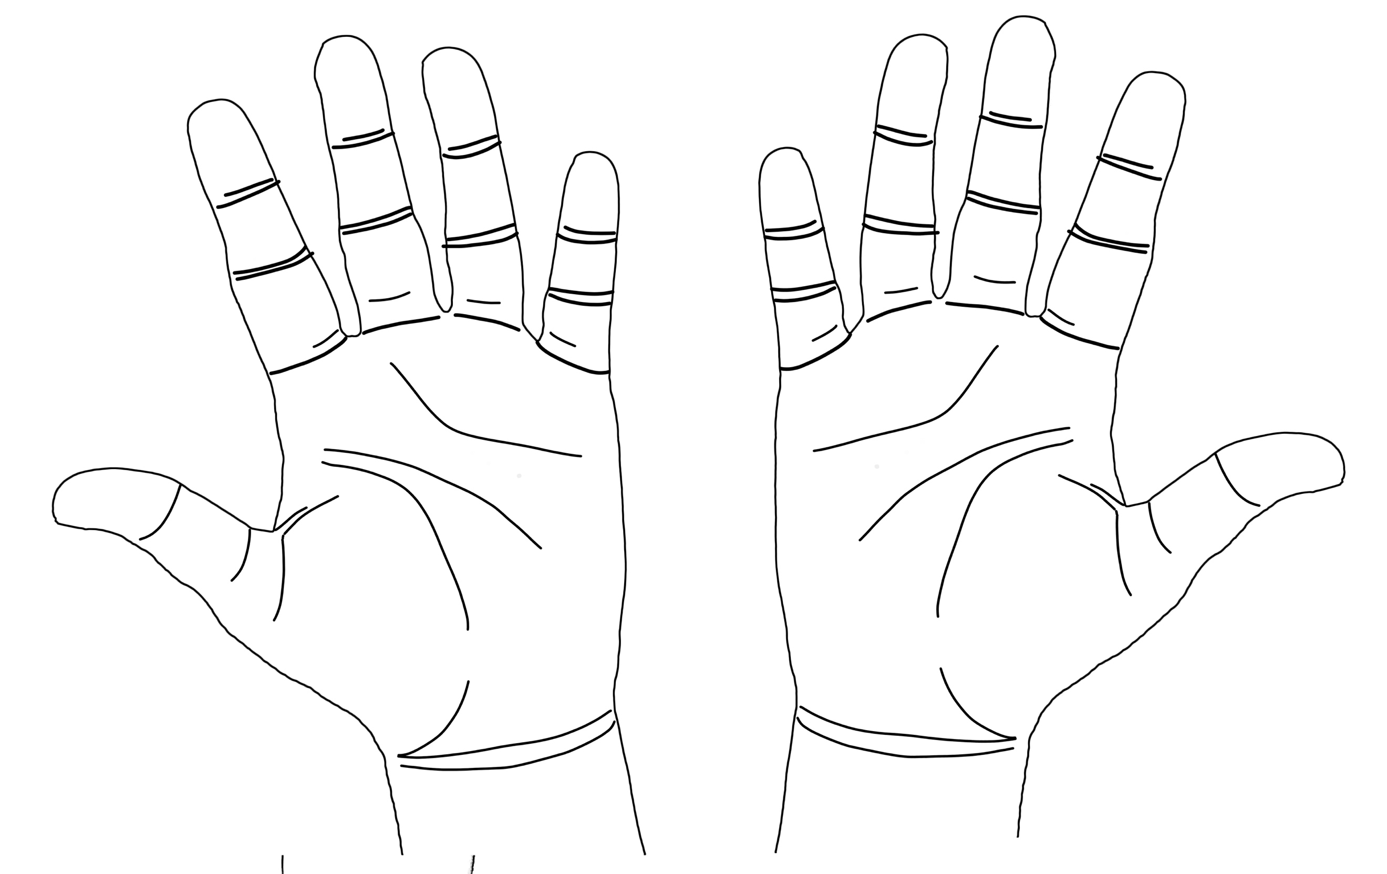
Left
Right

---------------------------------------------------------------------------------------------------------------------

By clicking on/shading the hand diagram (Left and Right) below, please show where you have experienced TINGLING (pins and needles sensation) on the back of your hands/fingers in the last month. (Click next if it does not apply)
Back of Hands
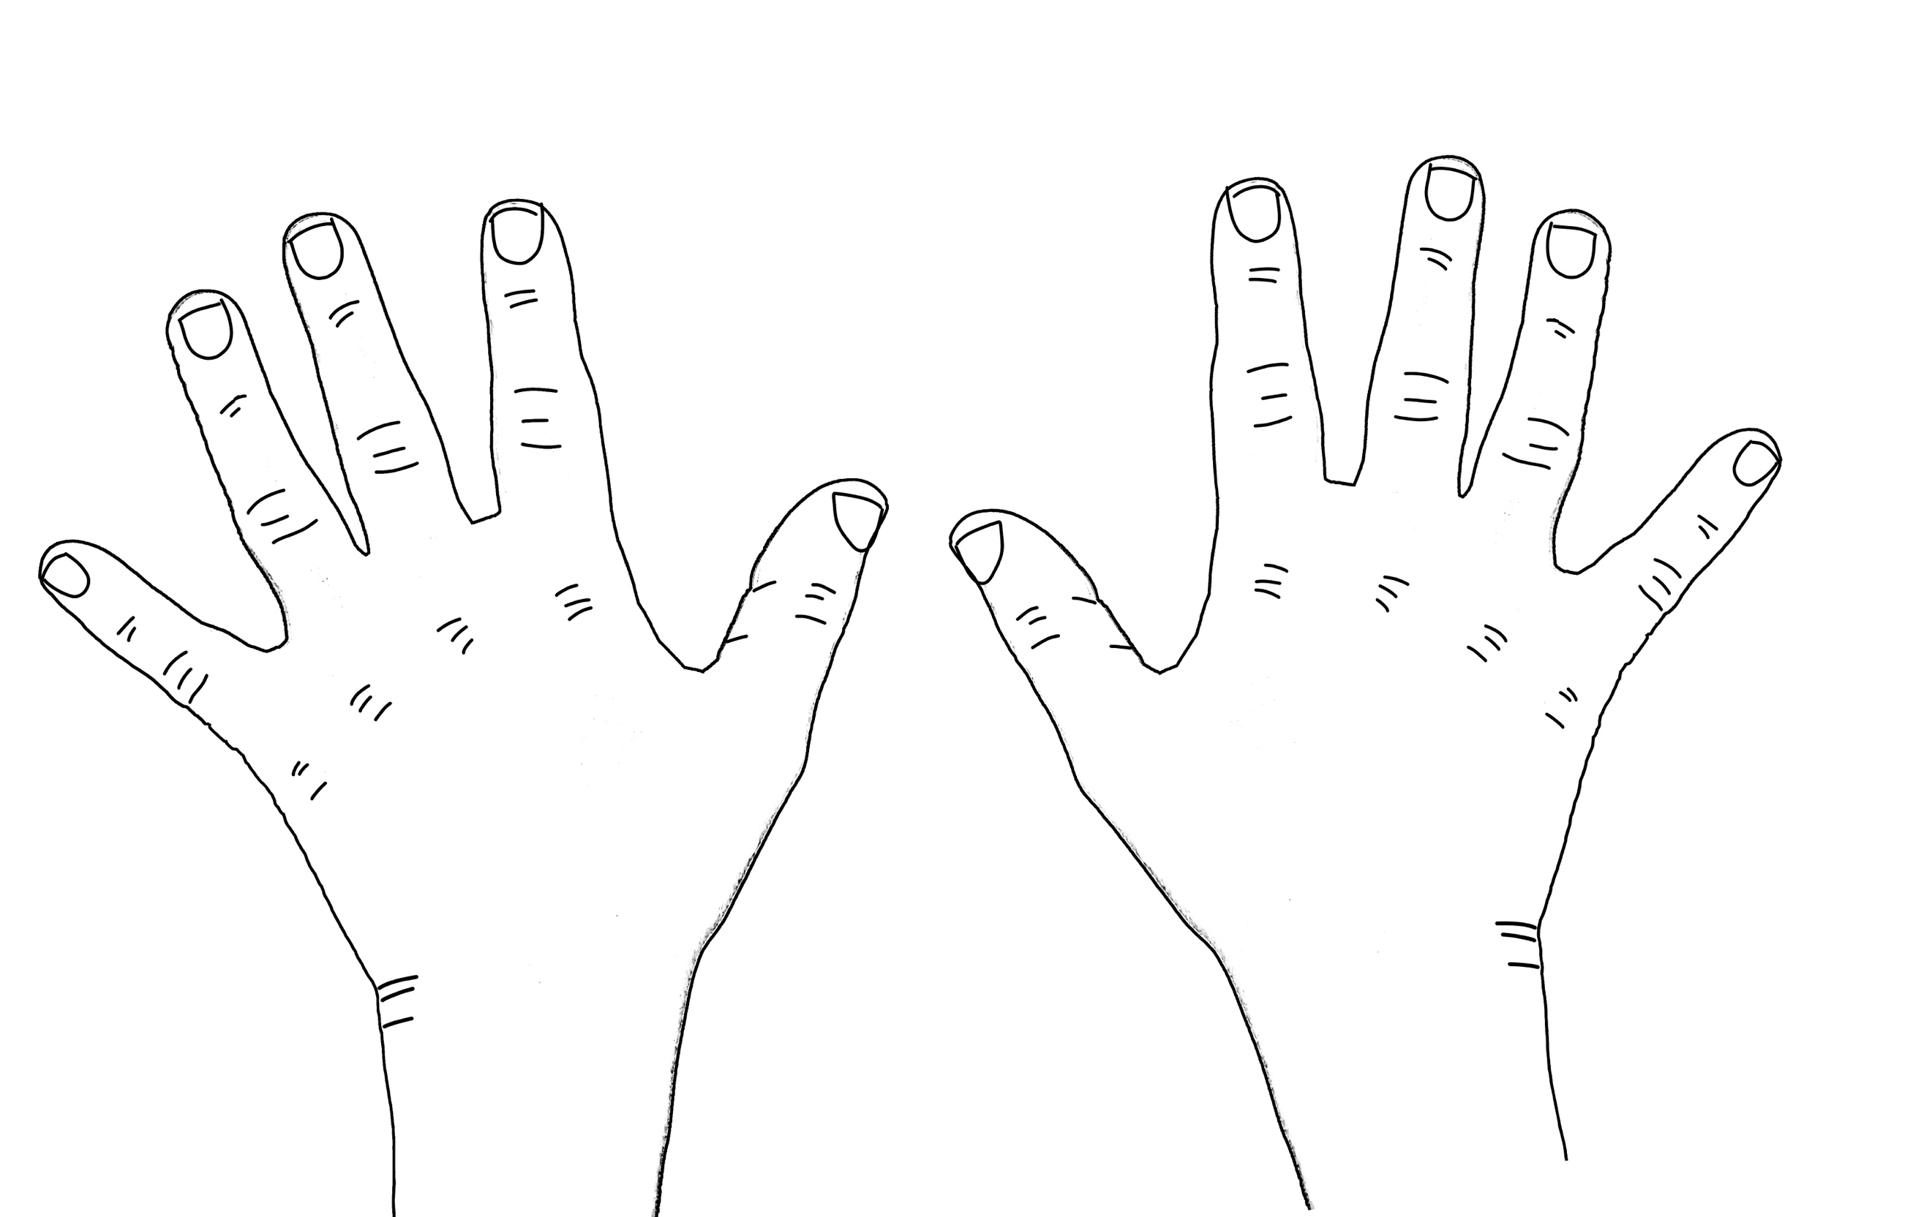
Left
Right

By clicking on/shading the hand diagram (Left and Right) below, please show where you have experienced NUMBNESS (no feeling or dead feeling) on the front of your hands/fingers in the last month. (Click next if it does not apply)

Front of Hands

Right
Left

---------------------------------------------------------------------------------------------------------------------

By clicking on/shading the hand diagram (Left and Right) below, please show where you have experienced NUMBNESS (no feeling or dead feeling) on the back of your hands/fingers in the last month. (Click next if it does not apply)
Right
Back of Hands
Left

---------------------------------------------------------------------------------------------------------------------
By clicking on/shading the hand diagram (Left and Right) below, please show where you have experienced PAIN on the front of your hands/fingers in the last month. (Click next if it does not apply)
Front of Hands

Right
Left

---------------------------------------------------------------------------------------------------------------------

By clicking on/shading the hand diagram (Left and Right) below, please show where you have experienced PAIN on the back of your hands/fingers in the last month. (Click next if it does not apply)

Right
Back of Hands
Left

--------------------------------------------------------------------------------------------------------------------

