**General principles (to do more with less pain)**

* Respect pain. If an activity causes you discomfort, try doing the task in a new way, take a break, or ask for help. If you experience pain for an hour or longer after completing an activity, try shortening how long you spend doing it the next time. If you can, it is best to **STOP before you have pain!**
* Avoid holding your arms in raised positions for prolonged periods of time. Adjust the height of your work surface to ease pressure on your shoulder joints.
* Opt for a smooth, circular motion when doing activities like dusting or washing a car. Limit repetitive arm motions, particularly sudden back-and-forth movements. Switch up your activities often to prevent pain and fatigue.
  + When you hold bag or tool, try to stretch your shoulder every 10 minutes. This can reduce stiffness and cramping.
* Avoid weight-bearing through your arms and use adaptive equipment if needed:
  + For getting on and off a chair, try using a high, firm chair, a raised cushion or chair blocks.
  + Use a shower or try a bathchair rather than getting in and out of the bathtub
  + Using a raised toilet seat can make it easier to get on and off the toilet.
* Exercise a little and often.
* It is good to continue everyday activities. It helps to keep your shoulders moving. But exercises can also help.

**Positioning your shoulders for good posture and less pain**

* Relax your arms at your sides
* Stand up right with chest lifted and expanded and tilt your neck slightly up
* Pull you shoulder blades back & down (like you were tucking them in a pocket)
* 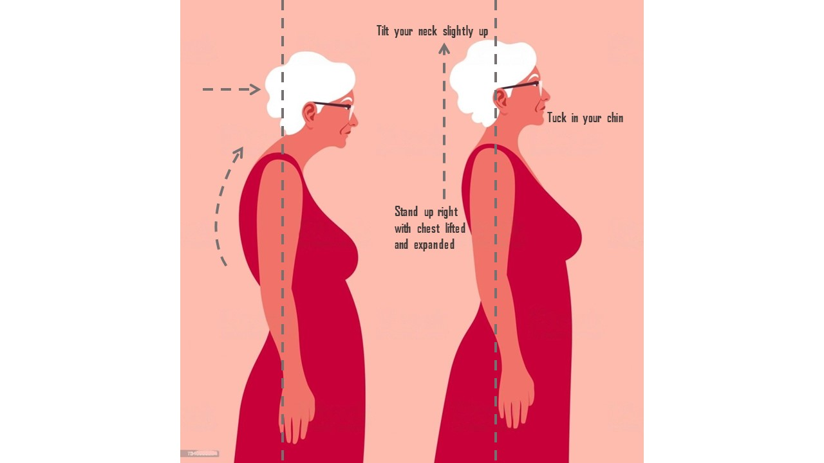Tuck in your chin with your head balanced over your body

**Suggestions for daily activities**

* **Dressing:**
  + Wear loose fitting clothing. Avoid tight turtlenecks and pullover sweaters.
  + Dress your most painful arm first and undress it last.



* **Grooming:**
  + Try adapted equipment to extend your reach, such as a long-handled comb, brush or sponge.
  + Use a hook to hang the blow-dryer or get a blow dryer stand so that you don’t have to hold it constantly.
  + Applying make-up, shaving etc.: Use your “good” arm to support the weight of the sore arm
  + Use an electric toothbrush to avoid repetitive back & forth motion
  + Use a long-handled sponge to reach your back
* **Kitchen related activities.**
  + ****When you invite family or friends for dinner, plan in advance. Prepare some things the day before. Ask others for help.
  + Adding a pull stick to bring the rack out and then use oven gloves to take a hot dish out of the oven. Then lift it out to the top of the stove and serve it there.
    1. Bend through the hip or squat down to reach the dish in the oven.
  + To serve a hot meal from a pan, leave the pan on top of the stove. Spoon it out from there.
  + To carry a tray or kettle: slide it on the countertop.
    1. Your elbow should be tucked against the body throughout the movement.
    2. Instead of reaching out with your arms, take a couple of side-steps to walk towards your destination.
  + Use lighter objects, like plastic bowls and lighter kettles.
  + Use electric appliances or a reacher to help you work: Electric knife, can opener, blender, food processor, electric screwdriver and table saw.
    1. Keep your knives sharp.
* **Cleaning and tidying**
  + To plan jobs around the house, give your shoulders a rest every 10 to 15 minutes.
  + To carry a basket of washed clothes, wrap your arms around the sides of the basket. Hold it close to your chest.
  + Pace yourself when vacuuming and do one room each day. Push the vacuum with 2 hands and keep the vacuum close to your body. Avoid repeatedly reaching out.
  + To iron clothes, slide the iron from the iron rest to the board. Try rocking from your hips instead of reaching across your body to iron.
  + To close a drawer, push it closed with your hip or thigh.
  + When cleaning the inside of windows, keep your shoulders close to the window as you wipe in circles. Don’t raise hands above head level.
* **Working**
  + Storage:
    1. Try to avoid over-reaching. Plan your worktop and storage areas so that items you use frequently are stored close to you, at a convenient height (between your shoulders and your knees).
    2. Store heavy items around waist height.
    3. Carry heavy items close to your body, supporting the weight against your body.
    4. Use a wheeled cart or office chair to move heavy items.
  + Surface Height:
    1. Your work surface is too high if it causes you to raise or hike your shoulders. Your desk height is correct if your shoulders are held in a relaxed position when your elbows are bent to 90°and your forearms are supported on your desk.
    2. If you need to work above shoulder level, position yourself as close as you can to your work, e.g. sit on a high stool to work at a bench or use a stepstool to reach an item from a shelf.
* **Driving**
  + When driving, move your seat forward to keep your body close to the steering wheel. This will keep your arms in a relaxed position with your elbows bent nearly 90 degrees.
  + Keep both hands on the steering wheel instead.
  + Keep your hands below the "3 o'clock" and "9 o'clock" positions on the steering wheel when driving.
  + Use your left hand to turn right and vice versa
    1. Same side of shoulder will experience the highest joint force during the turning (i.e. turn right cause highest force on the right shoulder joint)
  + Avoid twisting and awkward positions, such as reaching for objects in the back seat of a car from the front seat.
  + Use adaptive equipment
    1. Use a reacher to retrieve parking garage receipts from the machine.
    2. Use a telescopic-handle snow brush to clean the windshield.

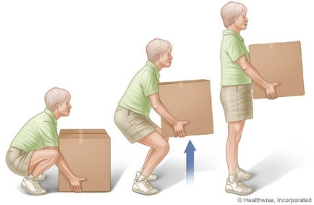

* **Carrying Heavy Objects**
  + Use a wheeled trolley or cart.
    1. Use both arms to push the cart.
    2. Leave enough space for turning.
    3. Lower the pushing level and standing close to the cart to avoid keeping your arms raised too high.
  + Use lightweight equipment.
  + Use both arms to carry grocery bags and keep the bags close to your body.
  + Crouch or bend with your legs before reaching to pick up an item from the floor
  + Use a "fanny" pack, a backpack with a hip belt or pockets, and cargo shorts to carry items.
  + Consider a delivery service or asking a friend or a family member to assist with bringing heavier items home.
* **Sleeping:**
  + ****If your shoulder is painful at night, use a pillow to support the full length of your arm or try a body pillow.
  + Avoid sleeping on the same side as your painful shoulder. If both shoulders are painful and you are not comfortable sleeping on your back, try a partial or " three-quarter" side lying position with a pillow in front of you to support the weight of your arm and maintain a neutral shoulder position.
  + A 2-inch thick foam pad on top of your mattress can help to accommodate the painful, bony parts of your shoulder joints.
  + Use your abdominal muscles and swing your legs off the bed first to sit up, instead of pushing up with your arms. Consider using a motorized bed can also position you in an easier position to rise from bed.
* **Computer & desk set-up**
* 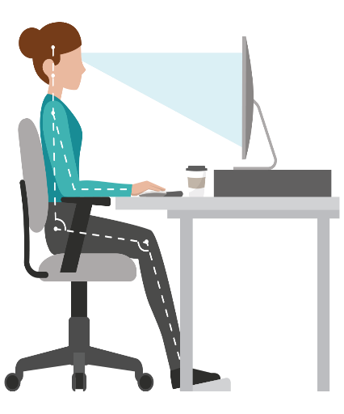Keep regularly used items within easy reach.
* Raise the computer monitor to a height where your eyes line up with the top 1/3 of the screen.
* Adjust your chair and/or keyboard tray so that you can type and mouse with your elbows bent to about 90° and your upper arms relaxed by your sides.
* Take frequent breaks to stretch and “reset” your posture.
  + Bring your shoulder blades down and back as if they are tucked in pockets on your back
  + Chin tucked; an imaginary string is pulling you straight up from the top of your
  + Use your chair armrests to support your arms when you take a break from typing
* If you find yourself straining your head and neck position while wearing bifocals to focus on the computer screen, consider using computer glasses. These glasses can adjust the position of the bifocal lens and promote better posture while using the screen.
* **Using smartphone**
  + Choose a lightweight smartphone and switching hands frequently
  + When use smartphone, try to keep arm close to the body.
  + Avoid holding the phone between your neck and shoulder
  + If you must use the phone for prolonged periods, consider a hands-free head set
    1. A smartphone stand or holder can also prevent shoulder injury
  + Move the phone to your better side to avoid reaching with the painful arm
  + Make the font size on your screen a little larger so it is easier to read.